**BDFII Assignment Screenshots**

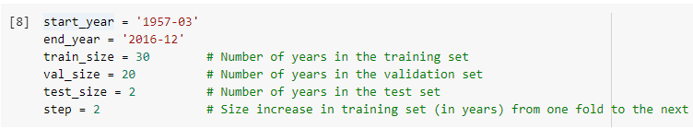Rolling window validation settings and visualisation:

**Q1 – Hyperparameter tuning (run time: 40min per model)**

**- With more memory space: should add ensemble=10**

**Full result for NN2, NN3 and NN4**

**Winning folds for each model**

**Q2 – Run best models (best set of hyperparameter) on test set (run time: 5min per model)**

**All Folds**

******Mean Score:**

*NN3 is the best performing model (out-of-sample).

**Q3a: Top 10 variable importance (run time: 30 sec per variable, about 1hr in total)**

**Q3b: Get a measure of joint importance of all macro predictors**

Note: drop in R2_OOS after setting macro variables to zero is much greater than stock characteristics. This suggests that macroeconomic condition (economic regime) has a bigger impact on individual stocks return than stock characteristics.

**Q3c: Get measure of sensitivity:**

**> For stock characteristics (run time: 1 hr):**

**> For all macro variables (joint):**

**Q4. Fit Penalised linear model (LASSO)**

**> Tuning of penalty (run time: 3 min)**

**> Out of Sample Testing (run time: 30 sec)**

Note: R^2 OOS of LASSO model not as high as R^2 OOS of neural networks (expected)